**Introduction**

Makers Making Change wanted to provide a tool for people with arthritis, low finger dexterity, or low vision to open beverage cans, and requiring only low strength and low accuracy to do so.

This device is not intended for tin cans that require pulling back the entire metal lid. For that, use this device [https://makersmakingchange.com/project/pull-tab-tin-can-opener/](https://makersmakingchange.com/?post_type=project&p=15035&preview=true).

**Requirements**

**Goals**

|  |  |
| --- | --- |
| G01 | To provide a way for people with low strength and accuracy to open the pull-tabs on beverage cans. |
| G02 | To provide a device cheaper than the commercial options. |
| G03 | To provide multiple handle options to accommodate different hand grips. |
| G04 | Work with both types of tabs (not just tabs with two holes– see Figure 1). |

**Functional Requirements**

|  |  |
| --- | --- |
| F01 | Must not deteriorate with daily use. |

**Non-functional Requirement**

|  |  |
| --- | --- |
| NF01 | All components must be 3D-printable with no supports. |

**Constraints**

|  |  |
| --- | --- |
| C01 | Must be less than $5 to produce. |

**Ideation**

Since there are many open-source designs available for opening beverages, it did not seem necessary to re-design a new product. Several designs that used different methods to open cans seemed promising. The various designs and their pros and cons are listed below in the testing section.

One particular concern with some of the designs was the difference in pull tabs. Some tabs had two holes while others lack the top hole, which many can opener designs rely on.

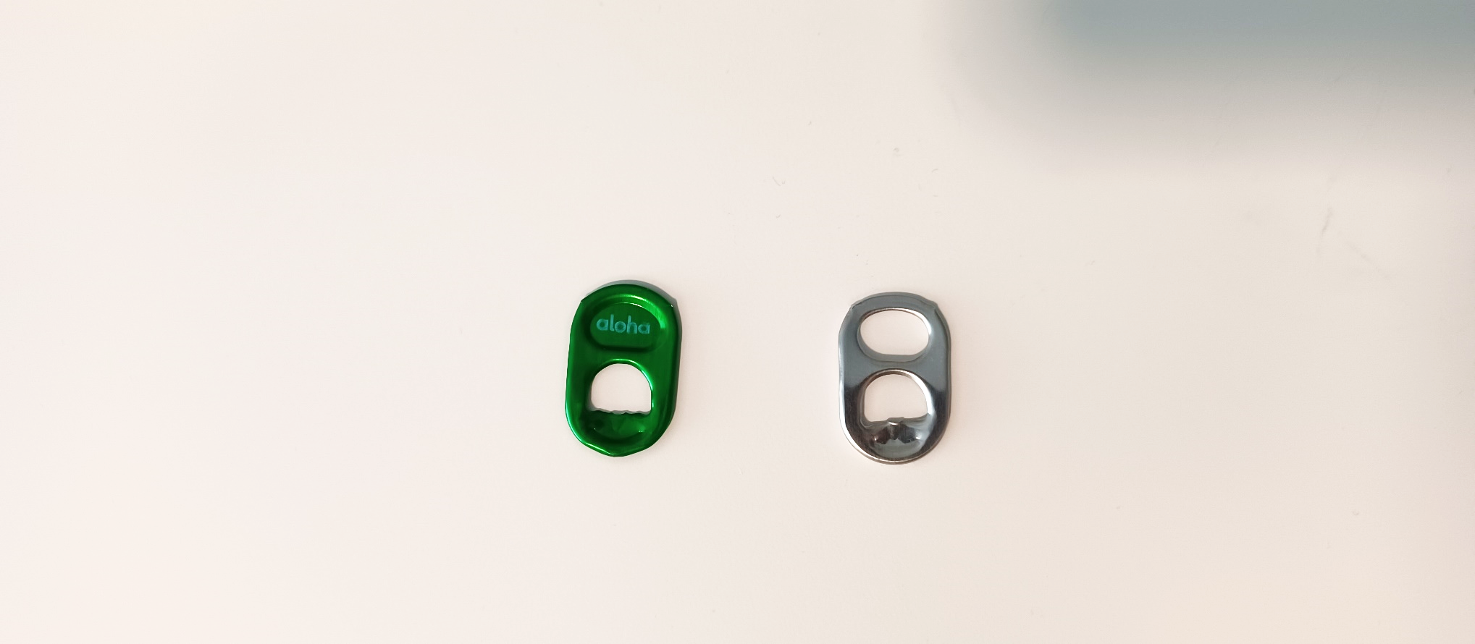

Figure 1: An image showing the difference in Can Tabs. The bubly™ can tab (left) lacks a hole which the generic pop can has (right). Other commercial drinks such as RedBull™ Energy drink lack the top hole as well.

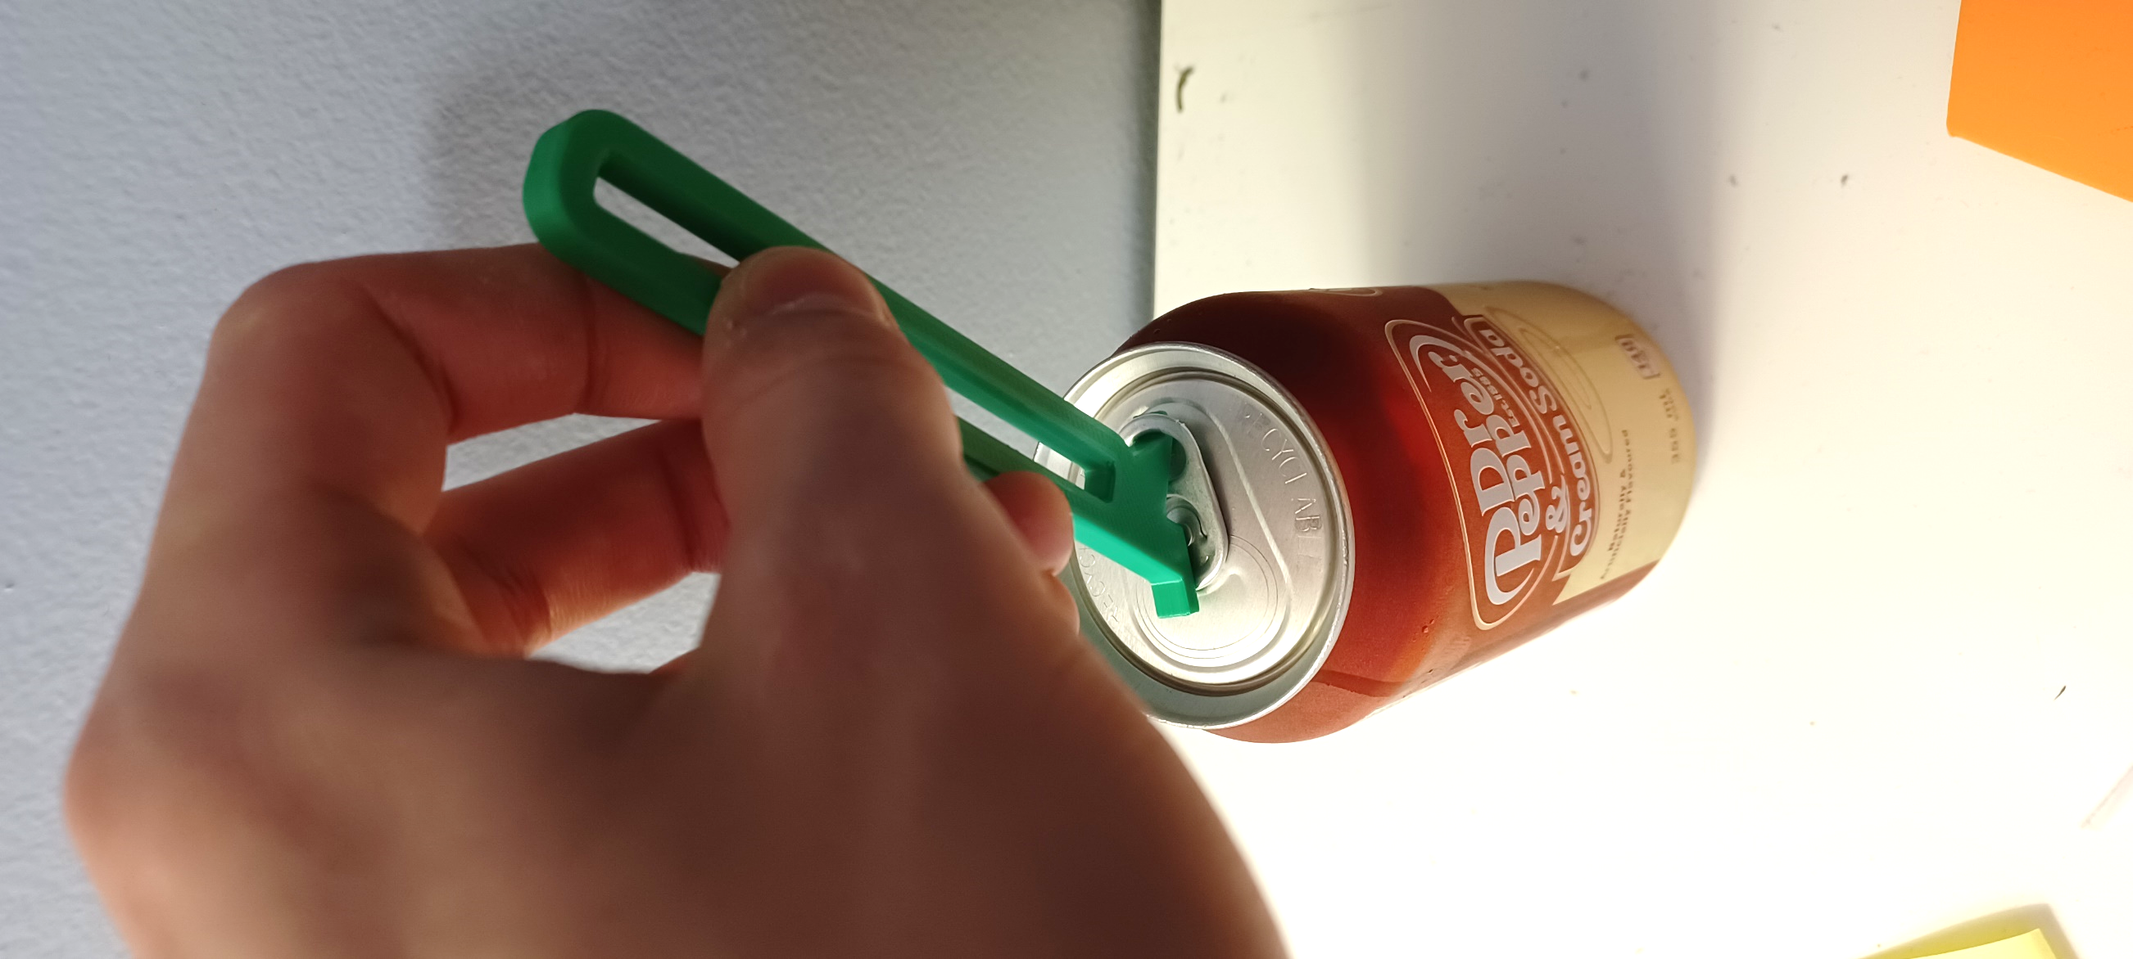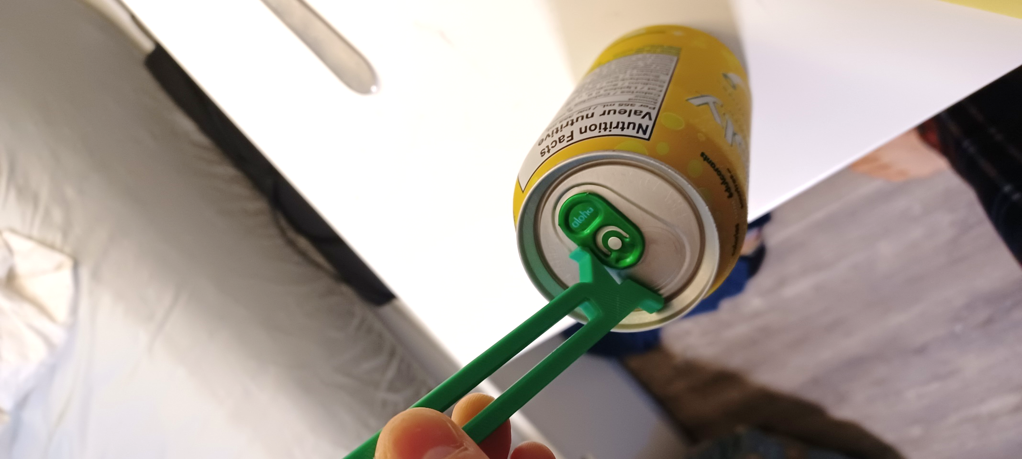

Figure 2: These 2 images demonstrate how a "hook-style" can opener cannot be used on a tab without a hole in the top.

**Testing**

A variety of open-source designs for can-openers were printed and tested for ease-of-use, ease-of-printing, and functionality.

### Design 1: Jason from PrintLabs

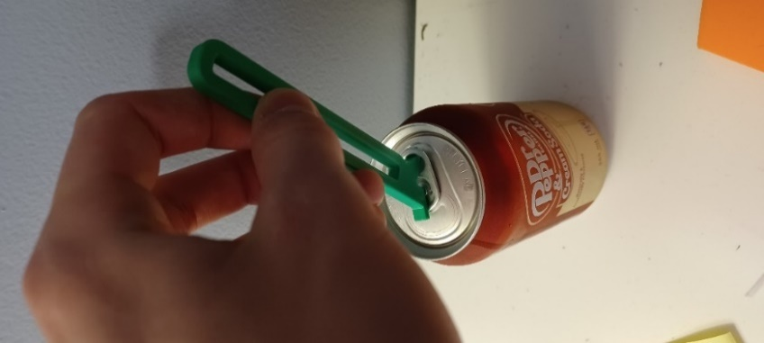

**Summary**

This design uses a hook to grab the pull-tab using the top hole, then a levering action to open the can. The handle is large, easy to hold, and the device is overall effective and easy to use.

**Pros**

* Easy and very quick to print (no support,~0.5 hours)
* Uses very little filament (~5 grams)
* Easy to use, large handle, lots of leverage

**Cons**

* Does not work on pull-tabs with a single hole

### Design 2: [Can opener and lid by osund - Thingiverse](https://www.thingiverse.com/thing:5386671)

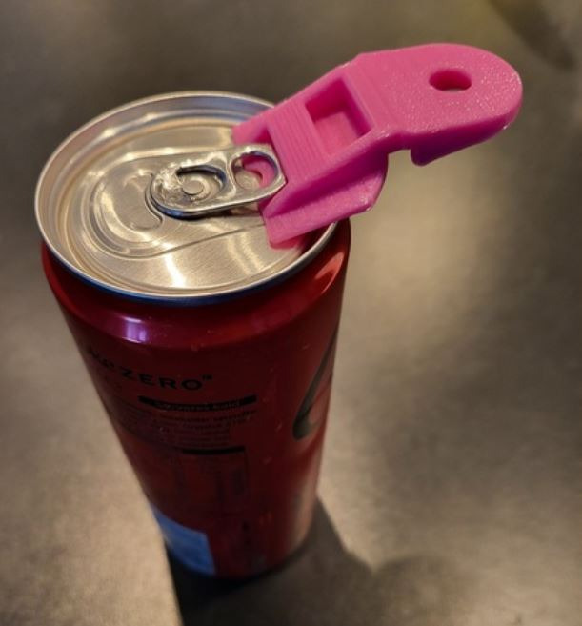

**Summary**

This is a small device which slides over the whole pull tab, allowing both tab styles to be opened. The small device size reduces print time and materials used. However, this comes at the expense of a difficult to hold and difficult to use device. This can opener also tends to slide off the tab during use, making for a somewhat frustrating experience overall.

**Pros**

* Very easy and quick to print (no supports, ~0.5 hours)
* Opens all styles of cans
* Slides over the pull-tab easily
* Also serves as a lid to protect drink from flies once opened

**Cons**

* Not very easy to use as the device easily slides off the pull-tab
* Doesn’t give much leverage

### Design 3: [Pop Top Can Opener - Final by VegasGuy - Thingiverse](https://www.thingiverse.com/thing:3027499)

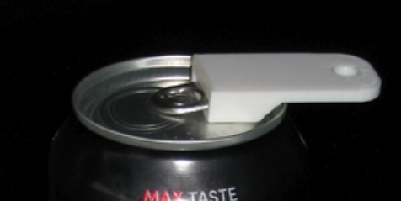

**Summary**

This device, like Design 2, slides over the whole pull-tab, allowing both tabs types to be opened. The Pop Top Can Opener is very small, making print time fast and uses less material, but is difficult to hold. However, this can opener is very effective, and for those with enough dexterity to hold the device, this Can Opener is probably the quickest and easiest to use on this list.

**Pros**

* Very easy and quick to print (no supports, ~0.5 hours)
* Opens all styles of cans
* Slides over pull-tab easily
* Easy to use, effectively opens cans

**Cons**

* Handle is tiny; can be difficult to hold
* Design is closed for derivatives

### Design 4: [OT student project : Can opener helper by Pole_ergo - Thingiverse](https://www.thingiverse.com/thing:3846323)

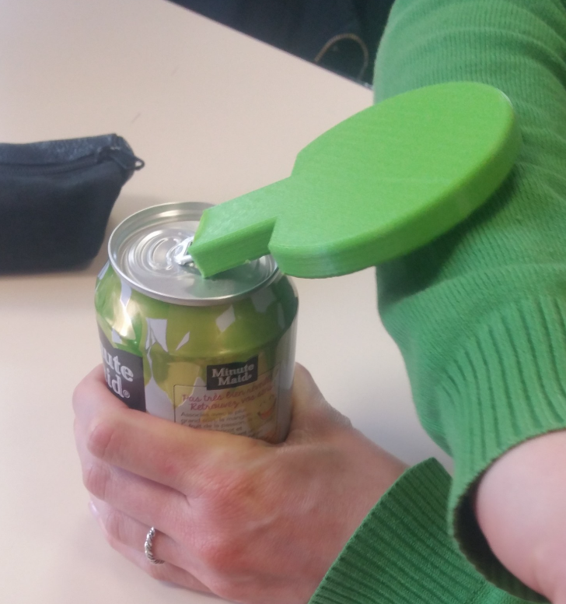

**Summary**

The Can Opener Helper by Ergo Pole is different than the other designs. It includes an extra large, paddle-like surface to leverage a can open using the elbow or wrist. However, the design is flawed in that it doesn’t grip the can-tab well and easily slides off. This would be an easy modification, however this design is closed for derivatives.

**Pros**

* Opens all styles of cans
* Slides over pull-tab easily
* Provides Larger Handle (Not sure how beneficial this is)

**Cons**

* Design is closed for derivatives
* Longer print time
* Doesn’t open cans as effectively as expected (reversible design makes can opener slide off)

**Summary**

This design works on both tab styles as it slides over the entire pull-tabs. The handle is nice to hold in the hand and the device easily and snugly slides over the pull-tab. However, this device often fails to open cans and instead bends the tab.

**Pros**

* Opens all styles of cans
* Slides over pull-tab easily
* Good size handle
* Double-sided

**Cons**

* Slightly longer print time (~1 hr)
* Will often bend tab instead of opening the can
* Does not reliably open generic pop cans

**Detailed Design**

All the designs that were tested either did not work with the single hole pull tab or was not suitable for those with arthritis and low finger dexterity. As a result, a new base design was created based on the Pop-Top Can Opener by [Thingiverse.com user Vegas Guy](https://www.thingiverse.com/vegasguy/designs), as shown below:

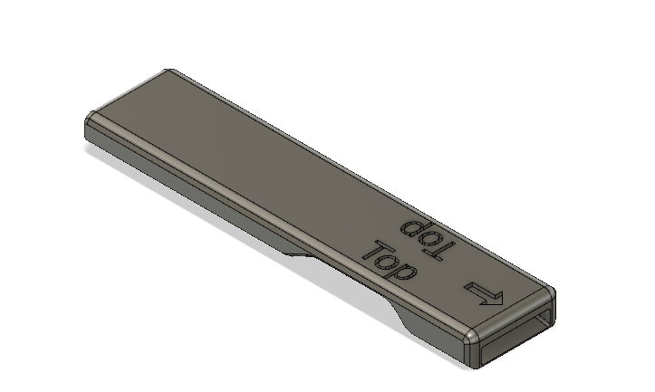

The Base Can Opener has a sloped hole which fits over almost all beverage can tabs. The device includes a graphic that describes which side should be facing upwards when opening the can and an arrow pointing towards the can opening. The device is designed to be used on its own or with the handle attached, as described below:

**Cylindrical Handle**

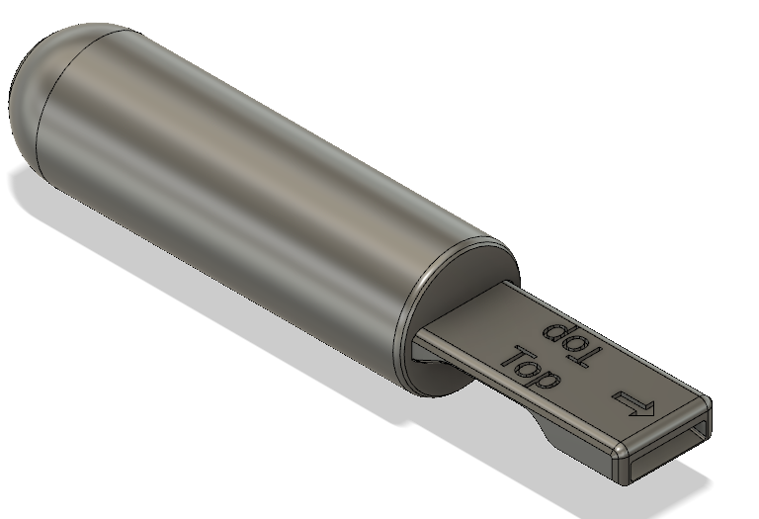

The Cylindrical Handle is 30 mm in diameter and 100 mm long. This handle is designed to fit the shape of a hand and is easy to grip for those with arthritis.

**Flat Handle** 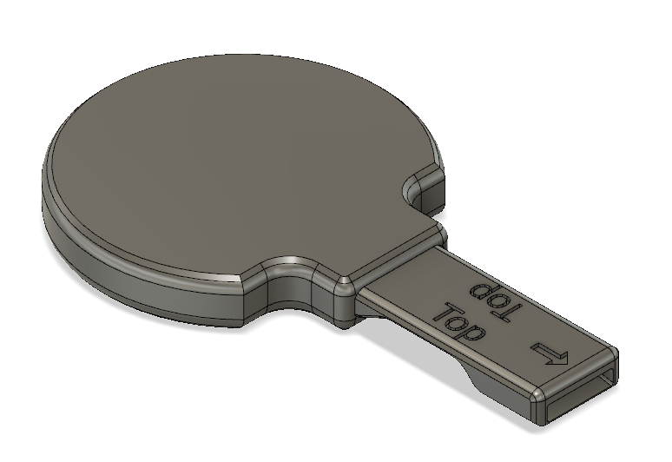The Flat Handle is designed for someone with limited hand function and uses the wrist or elbow to open the can. The outside radius of the circle, which forms the body of the flat handle, is 39 mm. The thickness of this handle is 12.6 mm.

**Loop Handle** 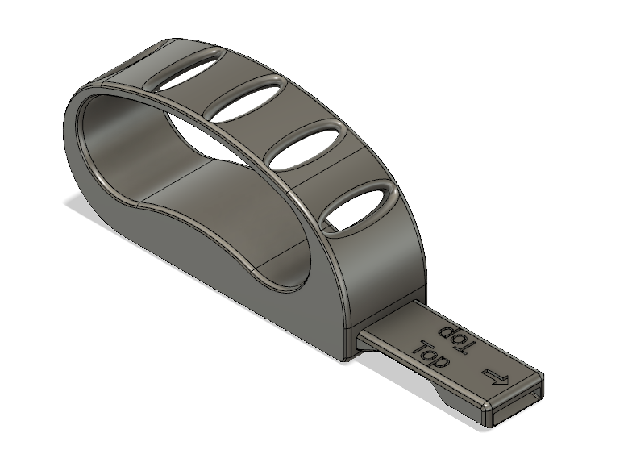

TheLoop Handle provides a way to open beverage cans without using any fingers. With the loop over the user’s hand, and a lifting and twisting motion is used to open the can. Dimensions for the Loop Handle are shown below:

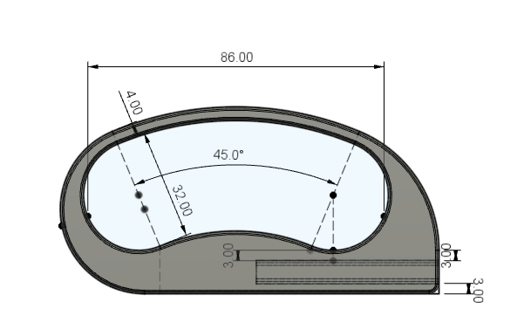

All three handles can be attached to the Base Can Opener. Each handle has the same sized hole for the base opener to tightly fit or super glued into. The dimensions for the standard hole for these handles are shown below:

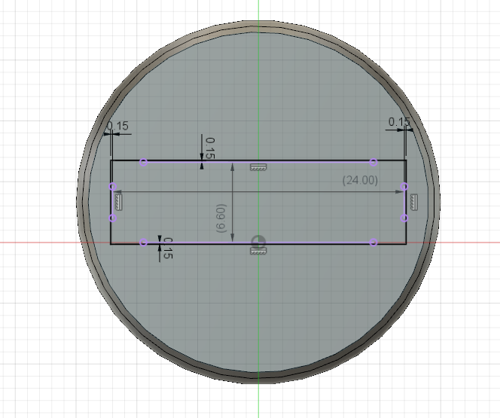

Each handle hole is the same size as the handle of the base can opener, which has a width of 24 mm, a height of 6.6 mm, plus a 0.15 mm clearance. Both the handle and the standard holes have a length of 53 mm.

#### Free Body Diagram

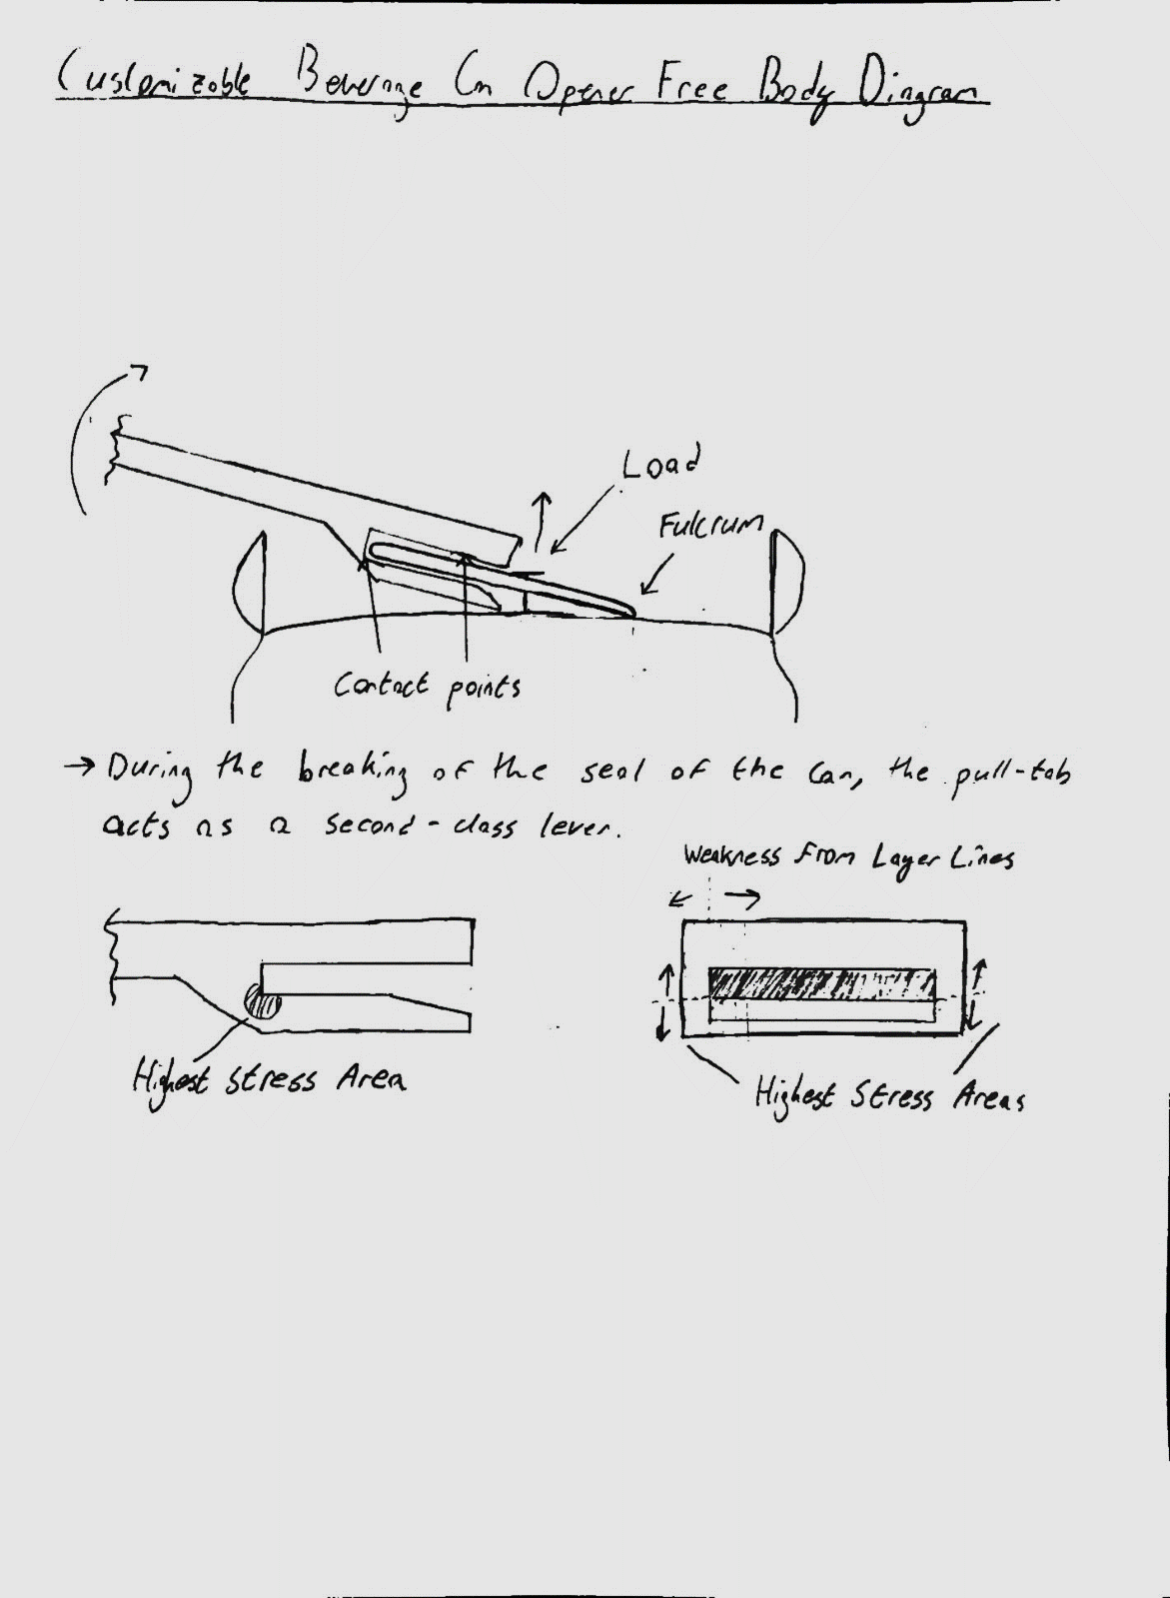

This free-body diagram shows the concentration of stress in the bottom left corner drawing. To relieve some of this stress, a fillet was added. Enough space for four 0.4 mm perimeter lines was given to this area, as shown in the picture below:

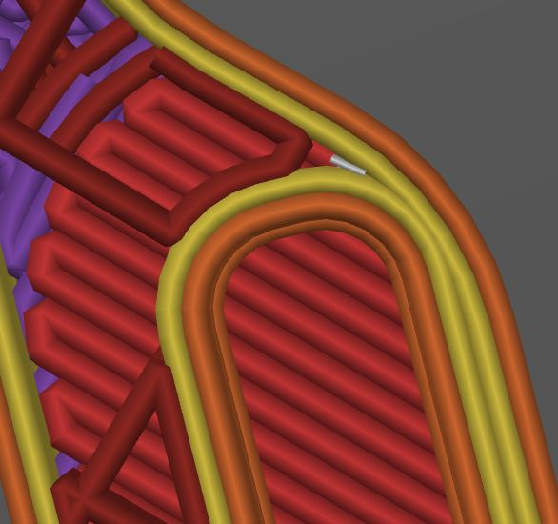

#### Print Orientation

The Base Can Opener was tested by printing it on its largest face and on its side (or the non-rectangular face). Printing on its side ensures that the surface contacts the pull-tab, is easily inserted onto the tab, and that the tab does not get caught between the layer lines. Additionally, this print orientation ensures that the force from opening the can does not get applied in the direction of the layer lines, as shown in the free-body diagram above.

#### Crush Ribs

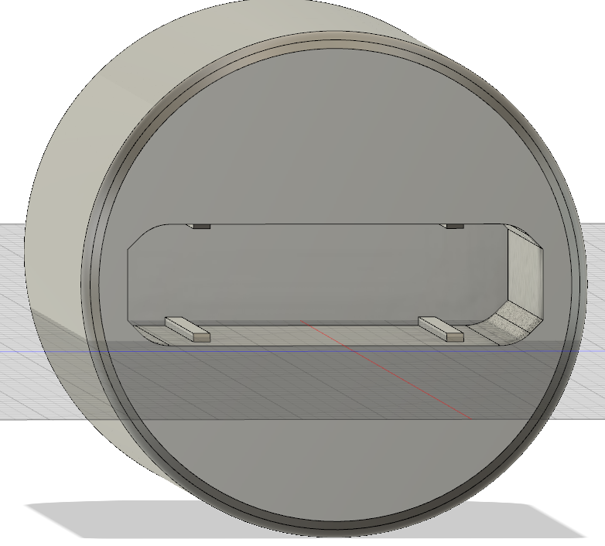

Crush ribs were added to the inside of all the handles to ensure a tight fit and plenty of tolerance for variations between different printers. The crush ribs are 0.5 mm tall and 1 mm wide. They start a small distance from the hole and have a chamfer so that the handle slides in easily.

**Opportunities for Improvement**

* Having two parts that fit together may be a problem that could be solved with a later iteration.